**THESIS TEMPLATE SETUP: WORD**

**Do NOT use Word Online/Google Docs/other apps to work on your thesis.  
Most of these are “lite” versions of the software and will corrupt your formatting.**

**Apply these settings the first time you work with the template on *any* computer. If you are working in a team, ensure all coauthors apply these settings as well.**Templates are available at [nps.edu/web/thesisprocessing/templates-forms](https://nps.edu/web/thesisprocessing/templates-forms)

**Windows: 365 and 2019 (earlier versions not supported):**

**Turn Off AutoFormat MANDATORY**

* From the **File** menu, select ***Options****.*
* From the left column, select ***Proofing****.*
* Click the ***AutoCorrect* *Options***button.
  + Select the ***AutoFormat As You Type*** tab (left screen shot)
    - Under ***Replace as You Type***, check all options.
    - Under ***Apply as You Type***, uncheck all options.
    - Under ***Automatically as You Type***, uncheck all options.
  + Select the ***AutoFormat*** tab (right screen shot).
    - Under ***Apply***, uncheck all options. Click *OK*.
    - Under ***Replace*,** check all options. Click *OK.*

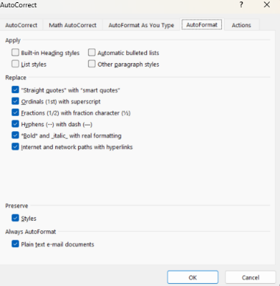

**Turn Off Keep Track of Formatting MANDATORY**

* Back on the ***Options***menu, select ***Advanced***from the left menu*.*
* Ensure *Keep track of formatting* is unchecked.

**Display the Styles List**

* Select the **Home** tab in the Ribbon.
* In the **Styles** panel, select the small arrow in the bottom-right corner of the panel.
* The template “Styles” list will be displayed on the right side of the document.
* Choose a style from this list to apply that style to an element of the document.

**Mac:**

**Turn Off Auto Formatting Options MANDATORY**

* From the Word menu, select ***Preferences****.*
* Select the ***AutoCorrect*** icon.
* Select the ***AutoFormat as You Type*** tab.
* **Uncheck** all options under ***Replace as you type****.*
* **Check** all options under***Automatically as you type*** (middle section of left screen shot)
* **Uncheck** all options under***Automatically as You Type*** (bottom section of left screen shot)

**Turn Off Keep Track of Formatting MANDATORY**

* From the **Word** menu, select ***Preferences****.*
* Select the ***Edit*** icon.
* Under ***Editing Options****,* uncheck ***Keep track of formatting*** (right screen shot)

**Display the Style List**

* The template styles are located at the top, in the Home tab, in the *Styles* pane.
  + Click ***Styles*** ***Pane***to display the styles
  + Under ***List*,** select ***Recommended****.*

